Want to start a White Cane Day in your area?
Here are some ways to start.

10 steps for planning an event:

-Develop event goals and objectives
-Organize a team
-Set a date
-Brand your event
-Create a Plan
-Determine administrative process
-Identify/establish partnerships and sponsorships
-Create a publicity plan
-Establish a budget
-Evaluate the event

Community Resource List:

-Local Blindness Chapters:
-American Council of the Blind (ACB)
-National Federation of the Blind (NFB)
-Lighthouses for the Blind
-Local small/large businesses
-TWC Vocational Rehab. Staff
-Office of disabilities
-Mayor’s Office
-Parks and Recreation Departments
-Support Groups:(Diabetic, Low Vision)

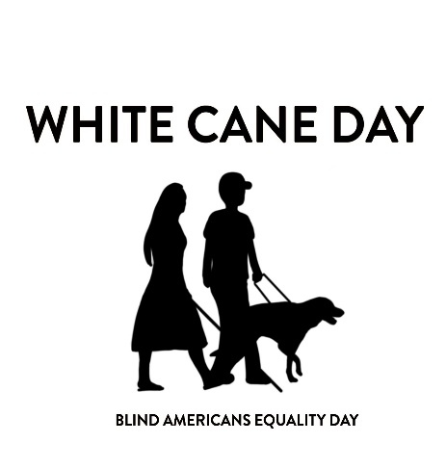
The mission of White Cane Day is to educate the world about blindness and how the blind and visually impaired can live and work independently while giving back to their communities, to celebrate the abilities and successes achieved by blind people in a sighted world and to honor the many contributions being made by the blind and visually impaired.

For More information Contact:
whitecaneday@twc.texas.gov

Alison Behringer: 512-284-3296 alison.behringer@twc.texas.gov

Juanita Barker: juanita.barker@twc.texas.gov

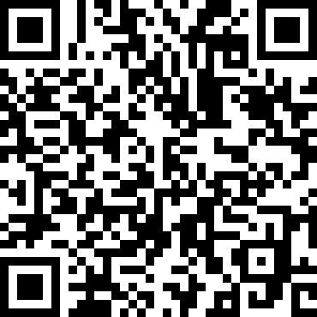

www.whitecaneday.org

The mission of White Cane Day is to educate the world about blindness and how the blind and visually impaired can live and work independently while giving back to their communities, to celebrate the abilities and successes achieved by blind people in a sighted world and to honor the many contributions being made by the blind and visually impaired.

For More information Contact:
whitecaneday@twc.texas.gov

Alison Behringer: 512-284-3296 alison.behringer@twc.texas.gov

Juanita Barker: juanita.barker@twc.texas.gov

www.whitecaneday.org

Want to start a White Cane Day in your area?
Here are some ways to start.

10 steps for planning an event:

-Develop event goals and objectives
-Organize a team
-Set a date
-Brand your event
-Create a Plan
-Determine administrative process
-Identify/establish partnerships and sponsorships
-Create a publicity plan
-Establish a budget
-Evaluate the event

Community Resource List:

-Local Blindness Chapters:
-American Council of the Blind (ACB)
-National Federation of the Blind (NFB)
-Lighthouses for the Blind
-Local small/large businesses
-TWC Vocational Rehab. Staff
-Office of disabilities
-Mayor’s Office
-Parks and Recreation Departments
-Support Groups:(Diabetic, Low Vision)

